Database Design Example – Find a good database design by Normalization

Initial schema:

Landing-schema = (branch-name, branch-city, assets,
customer-name, loan-number, amount)

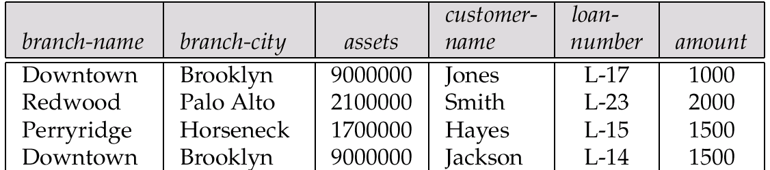

It is satisfy the First-Normal form without multi-valued attributes. But it is not a “good” design due to:
- Data for branch-name, branch-city, assets are repeated for each loan that a branch makes
- Wastes space
- Complicates updating, introducing possibility of inconsistency of assets value

Second Normal Form - Requires that any non-key field be dependent upon the entire key. For example, consider the above table, where branch-name and load-number form a compound primary key.

The branch-city and assets only depend on branch-name but does not depend at all on loan-number. Customer-nmae and amount only depend on loan-number but not on branch-name. This Data should be split into three tables as follows.

Branch (branch-name, branch-city, assets)
Branch-name is the primary key
Loan (loan-number, branch-name, customer-name, amount)
Laon-number is the primary key

This is assuming that a loan only can have one customer. If there is a join-loan which has more than one customer for a loan-number, then customer-name is not depend on loan-number. Then we should further separate the schema as the following:

Branch (branch-name, branch-city, assets)
Branch-name is the primary key
Loan (loan-number, branch-name, customer-name, amount)
Loan-number is the primary key
Borrower (loan-number, customer-name)
Primary key is loan-number and customer-name combine

